**1. What are three conclusions we can make about Kickstarter campaigns given the provided data?**

Firstly, the analysis helped us list those categories with highest completion/success ratios: theater, music and film/video with 34%, 17% and 13%, respectively. On the other hand bottom three categories were publishing, food and journalism with success ratios of 6%, 5% and ~1% respectively.

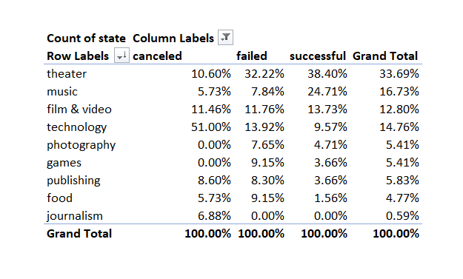

Figure : Crowd-funding success by category

Moreover, this paper also listed sub-categories individually while creating a column chart as shown below. Those categories with the highest figures of successful campaigns were plays, rock music as well as documentary production as shown briefly on below chart:

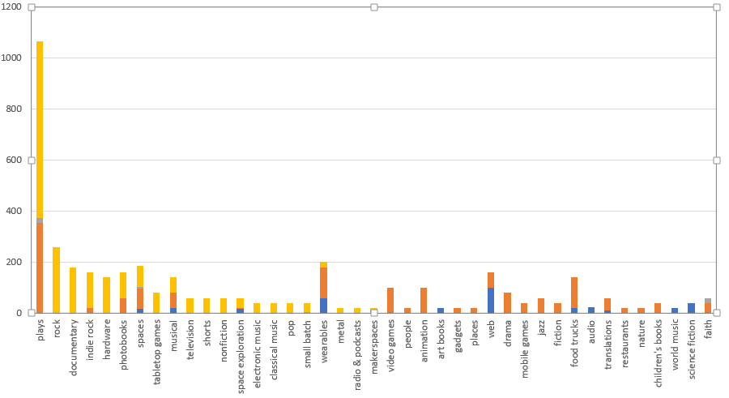

Figure : Crowd-funding success by sub-category

Lastly, the analysis showed the best months of the year for the crowd-funding operations were May, June and February with 234, 211 and 202 successful campaigns, respectively.

**2. What are some of the limitations of this dataset?**

The data set briefly showed us crowd-funding activities with a scope of a certain time period while this could also be considered as a limitation due to ever-changing nature of business world.

**3. What are some other possible tables/graphs that we could create?**

The analysis could also extend beyond the information in hand since a lot more financial aspects of crowd-funding might be examined in order to have a brief idea regarding these business operations and services.